9 Science Bohr Electron Shell Diagrams
Finish the diagram by writing the number of (n) – neutrons and (p)-protons found in a Potassium nucleus, and shade in the inner most electron shells with the appropriate number of electrons.

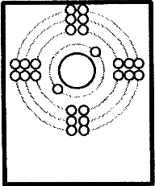
Potassium
Rules for filling in
electrons in a shell diagram.

For each of the following Shade the shells and add the number of protons and neutrons in the nucleus:
Hydrogen  Electron #  ______  Valence #  ______ | Helium  Electron #  ______  Valence #  ______ | Lithium  Electron #  ______  Valence #  ______
Beryllium  Electron #  ______  Valence #  ______ | Boron  Electron #  ______  Valence #  ______ | Carbon  Electron #  ______  Valence #  ______
Nitrogen  Electron #  ______  Valence #  ______ | Oxygen  Electron #  ______  Valence #  ______ | Fluorine  Electron #  ______  Valence #  ______
Neon  Electron #  ______  Valence #  ______ | Sodium  Electron #  ______  Valence #  ______ | Magnesium  Electron #  ______  Valence #  ______
Aluminium  Electron #  ______  Valence #  ______ | Silicon  Electron #  ______  Valence #  ______ | Phosphorous  Electron #  ______  Valence #  ______
Sulphur  Electron #  ______  Valence #  ______ | Chlorine  Electron #  ______  Valence #  ______ | Argon  Electron #  ______  Valence #  ______

